Navigating e-CImpact
  - Guide to Applying for the Anti-Bias Teacher Grant from United Way

Creating an account in e-CImpact
- From “Apply” link on the webpage, create an e-CImpact account, then click “Next” on the following page.
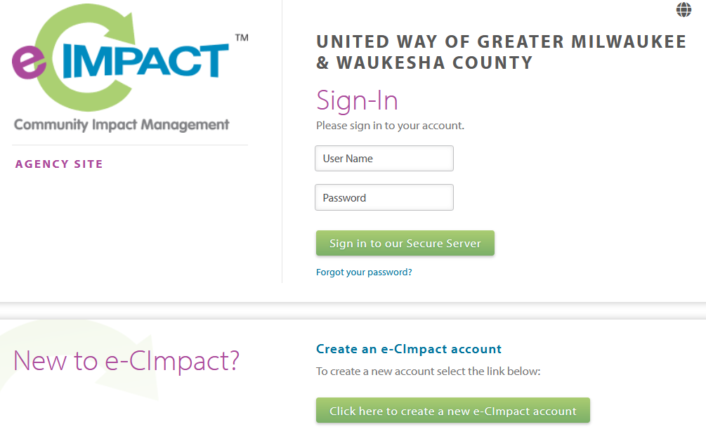
- Complete the required fields marked with an asterisk (*). For “Agency Name,” type your own name. Skip unrequired fields that don’t apply.
- Choose “Anti Bias Teacher Grant.”
- Answer the eligibility screener questions, then click “Continue.”
- You’ll receive two confirmation emails from admin@e-cimpact.com almost immediately. Check your spam or junk folder if you don’t receive them.
- Click the link and log in with your newly created username and password.

Completing the Application on e-CImpact
- To ensure your answers are saved, we recommend saving often or drafting answers in a separate document and pasting them into e-CImpact once finished.
- After logging into your e-CImpact account, find the Anti Bias Teacher Grant on your home page.
- Begin Section 1. When finished, click “Save My Work and Mark as Completed” at the bottom of the page.
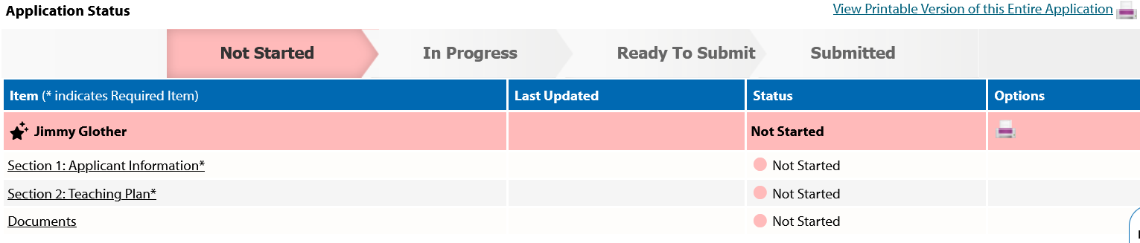
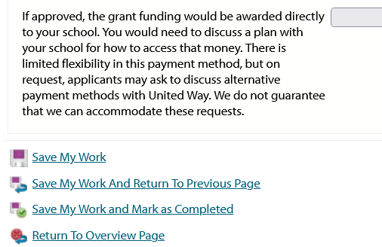
- The status and color will change for that section. Complete Section 2 and mark as completed.
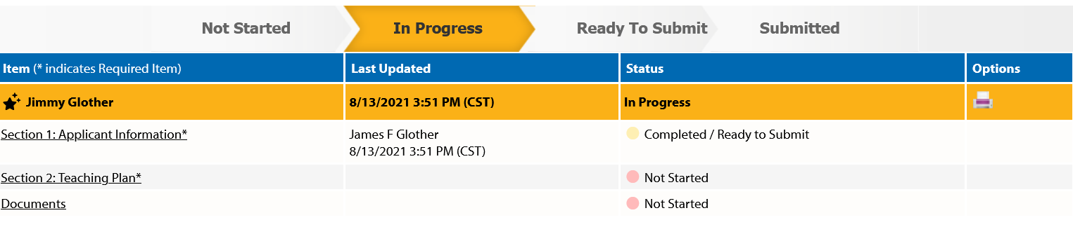
- The section named “Documents” allows you to upload optional documents, but you’ll need to mark it as completed in order to submit.
- Once all sections are marked completed, a red button will appear. Clicking it will officially submit your application and block you from making further changes, so be sure your report is final before submitting. A confirmation email will be sent to the address listed on the page.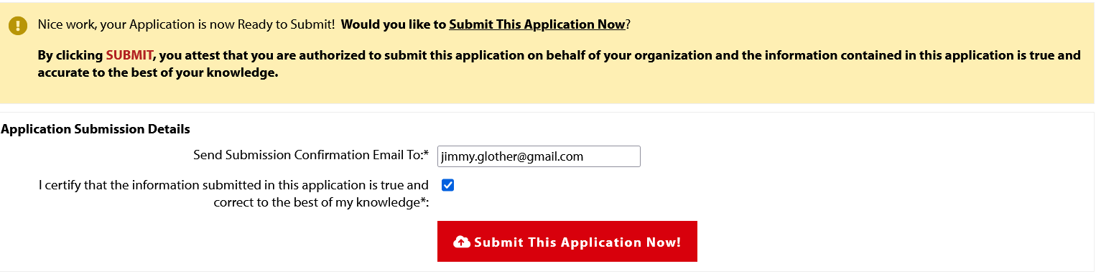
- If you submit by mistake or need to make changes before September 20, you may email Dawn Helmrich at dhelmrich@unitedwaygmwc.org to request that she reopen your application for you to make edits. Requests on or after September 20 will not be granted.

