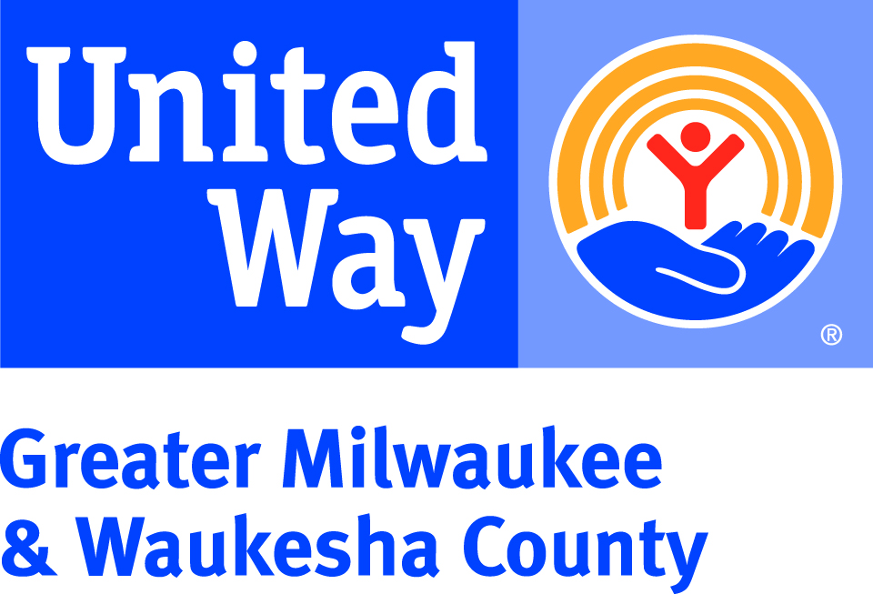
UNITED WAY “FACT A DAY”
Fact #1 – United Way’s invests in local programs in the areas of health, education, and financial stability because these are the building blocks to a good quality of life. We all win when a child succeeds in school, when families have good health, and when workers have solid jobs.
Fact #2 – A single gift to United Way literally helps hundreds of thousands of people. Last year, 243,053 people accessed services through United Way-funded programs and partnerships across our community.

Fact #3 – United Way fights so community members have access to resources to meet their basic needs. Since 2009, more than 400,000 struggling community members received food, transportation, legal, and housing support through United Way-funded programs.
Fact #4 –United Way’s Boys & Men of Color portfolio was created to prioritize the developmental needs of boys and men of color throughout our region. This portfolio expands United Way’s partnership with community-based organizations, youth and adult residents, law enforcement, education, health systems, and faith-based advocates to collectively address the challenges faced by males of color in our community.
Fact #5 – United Way fights for families facing economic challenges to maximize their tax returns. In 2017-18, 14,987 tax returns were filed under the United Way-funded Volunteer Income Tax Assistance program and $6,950,917 dollars were returned to local families.
Fact #6 – A gift to United Way’s Community Fund is the most strategic way to invest in the community. Our community’s problems are interrelated, and only the Community Fund’s diversity of funded programs work together to address the complex causes of poverty, teen pregnancy, homelessness, and many others – in a way that no single agency, donor, volunteer, or sector of the community can do alone.
Fact #7 – United Way fights for young people to delay becoming parents until adulthood. Since 2009, the community’s teen birth rate (15 – 17 year olds) has declined by 65% thanks in part to the United Way-led Teen Pregnancy Prevention strategy.
Fact #8 – Who doesn’t love back-to-school shopping? In 2018, United Way’s Backpack Coalition mobilized thousands of volunteers and donated resources to pack more than 5,600 backpacks for children in both Milwaukee and Waukesha Counties.
Fact #9 – United Way is a proud partner in the Milwaukee Community Schools Partnership (MCSP), a collective strategy to transform schools into a place where students, families, staff, and the surrounding community can work together to ensure every student is successful. The two longest-running Community Schools have shown increased graduation rates and students’ math and reading scores have shown double the rate of growth when compared to the rest of the district.
Fact #10 –- United Way has set a goal: end family homelessness in our community by 2025. Your gift to United Way’s Safe & Stable Homes Initiative will allow United Way to invest in prevention resources for families who are at risk for homelessness.
Fact #11 – In 2018, United Way responded to the extreme cold weather by funding warming rooms and providing resources to increase the capacity of local nonprofits that provide food and shelter to struggling individuals and families.

Fact #12 – United Way fights for the safety of people experiencing intimate partner violence. Since 2009, an average of 9,500 people are served per year in United Way-funded intimate partner violence programs across Milwaukee, Ozaukee, Washington, and Waukesha counties.
Fact #13 – Volunteers transform communities. In 2018, United Way volunteers gave over 42,000 hours of time to improve our community, with an estimated value of $1,040,091 in volunteer time.
Fact #14 – When a child can read proficiently by 3rd grade, they are set up for success for the rest of their school career. Through the My Very Own Library and Build My Bookshelf programs, United Way and Scholastic, Inc. have distributed more than tens of thousands of free books to local students to build their own home libraries.
Fact #15 – Project Homeless Connect is an annual event that immediately connects people experiencing homelessness to services like dental and vision screenings, employment resources, and housing assessments. In 2018, an estimated 720 individuals accessed resources from 80 providers at the event.

