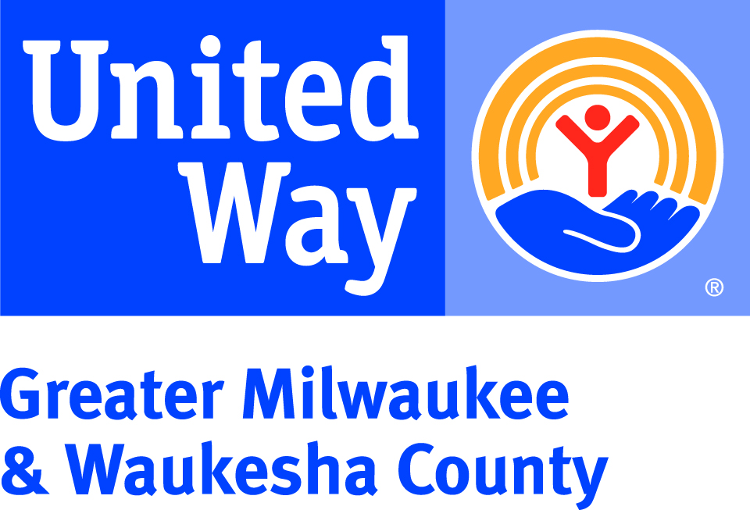
UNITED WAY “FACT A DAY”
Fact #1 – United Way’s invests in local programs in the areas of health, education, and financial stability because these are the building blocks to a good quality of life. We all win when a child succeeds in school, when families have good health, and when workers have solid jobs.
Fact #2 – In 2018, United Way will continue to support programs at GPS Education Partners, Wisconsin Community Services, and the School District of Waukesha to impact the highest-need schools in the Waukesha School District through the Helping Kids Succeed initiative.

Fact #3 – United Way fights to increase the number of adults and children who have access to quality, affordable health care. Last year, United Way donors ensured that more than 16,300 local individuals were connected to health and dental care.
Fact #4 –United Way’s Boys & Men of Color portfolio was created to prioritize the developmental needs of boys and men of color throughout our region. This portfolio of local programs an initiatives expands United Way’s partnership with community organizations, youth and adult residents, law enforcement, education, health systems, and faith-based advocates to improve outcomes for males of color in our community.
Fact #5 – United Way invests in programs that support caregivers. Last year, 99% of surveyed caregivers from United Way-funded disabilities programs felt that they understood their rights and had learned how to advocate for the person they care for.
Fact #6 – A gift to United Way’s Community Fund is the most strategic way to invest in the community. Our community’s problems are interrelated, and only the Community Fund’s diversity of funded programs work together to address the complex causes of poverty, teen pregnancy, homelessness, and many others – in a way that no single agency, donor, volunteer, or sector of the community can do alone.
Fact #7 – Last winter, United Way provided urgent need funding to support local warming rooms and overflow shelters during cold winter days, and purchased new winter coats, gloves, and hats for children and teens who recently relocated to Milwaukee from Puerto Rico following hurricane devastation.
Fact #8 – Who doesn’t love back-to-school shopping? In 2017, United Way’s Backpack Coalition mobilized thousands of volunteers and donated resources to pack more than 4,900 backpacks for children in both Milwaukee and Waukesha Counties.
Fact #9 – United Way is a proud partner in the Milwaukee Community Schools Partnership (MCSP), a collective strategy to transform schools into a place where students, families, staff, and the surrounding community can work together to ensure every student is successful. To date, all MCSP schools have demonstrated increased graduation rates.
Fact #10 –- Want to make a positive impact in a child’s life? Join United Way’s Emerging Readers Program and you will be assigned one local child to share books with four times a year. This is a great opportunity for families to give back together. Visit UnitedWayGMWC.org/Emerging-Readers to learn more.
Fact #11 – Research shows that having even small educational savings raises children’s expectations for their future and can increase the level of education that they attain. United Way has been part of the planning team for a citywide initiative to open Children’s Savings Accounts (CSAs) to help students save, plan, and pay for education costs after high school.

Fact #12 – United Way invests in the prevention and treatment of opioid abuse. In 2018, United Way made a grant to Sixteenth Street Community Health Centers Waukesha clinic to offset the costs of providing alcohol and other drug abuse counseling to under- and un-insured residents in both English and Spanish. This grant will cover the cost of 500 patient visits.
Fact #13 – Volunteers transform communities. In 2017, United Way volunteers gave over 38,400 hours of time to improve our community, with an estimated value of $928,331.
Fact #14 – When a child can read proficiently by 3rd grade, they are set up for success for the rest of their school career. Through the My Very Own Library initiative, United Way and Scholastic have distributed more than 70,000 free books to local students to build their own home libraries.
Fact #15 – Project Homeless Connect is an annual event that immediately connects people experiencing homelessness to services like dental and vision screenings, employment resources, and housing assessments. In 2017, an estimated 477 individuals accessed resources from 80 providers at the event.

