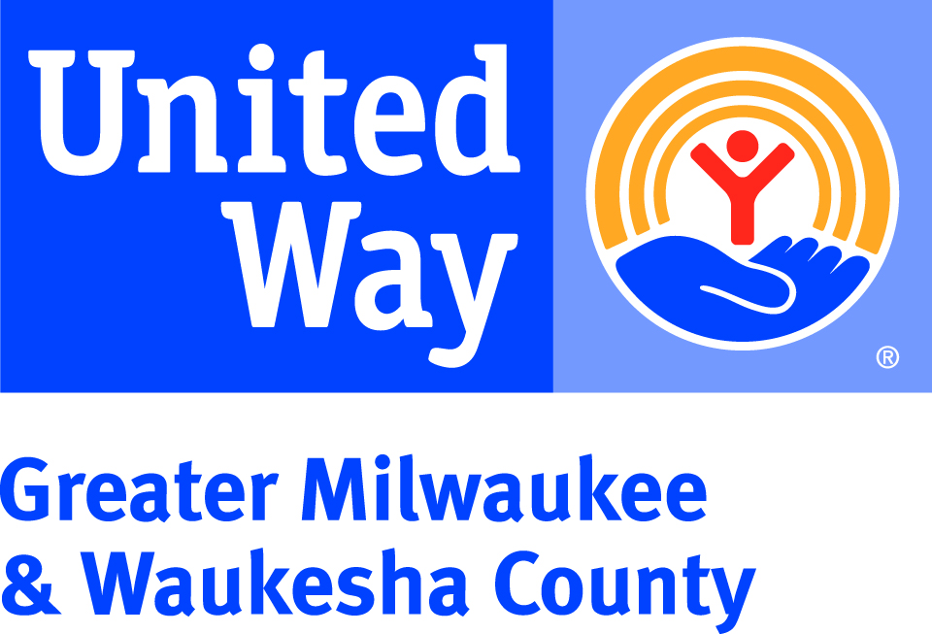
UNITED WAY “FACT A DAY”
Fact #1 – United Way’s invests in local programs in the areas of Health, Education, and Financial Stability because these are the building blocks to a good quality of life. We all win when a child succeeds in school, when a neighborhood turns around, when families have good health, and when workers have solid jobs.
Fact #2 – If a child cannot read proficiently by 3rd grade, they may never catch up enough to graduate from High School. United Way invests in 48 Education programs, and 83% of children who participated in United Way-funded programs last year improved their literacy skills.
Fact #3 – The money that is raised here, stays here. By investing in 220+ local programs at over 110 local agency program partners in Milwaukee, Waukesha, Ozaukee & Washington Counties, United Way is helping ensure that your donation is used to improve the quality of life right here in our community.
Fact #4 –Last year, close to 10,000 individuals and more than 100 groups invested in our community by participating in United Way’s Season of Caring. They volunteered a total of 21,124 hours, doing everything from planting a garden to reading to children to helping an older adult stay in their home. United Way can create a custom volunteer experience for you, your work group or your family. Visit UnitedWayGMWC.org/Volunteer to learn more.
Fact #5 – United Way invests in programs that help adults improve their education level and create a more financially secure future for themselves and their families. Last year, 99% of the adults who utilized United Way-funded adult learning programs made progress toward academic goals.
Fact #6 – Giving to United Way’s Community Fund is the most efficient and most powerful way to invest in your community. It combines the generosity of thousands of donors into a powerful financial resource, and your gift is monitored to ensure the programs are effective, meet current community needs, and are financially stable and sustainable.
Fact #7 – Last year, United Way hosted the 10th annual Ready, Set, Work! Women’s Job Seminar in Milwaukee and expanded this best practice by launching the inaugural Waukesha Women’s Job Seminar. More than 150 local women facing barriers to employment were matched one-on-one with resume, interview, and basic budgeting coaches to sharpen their skills.
Fact #8 – In the State of Wisconsin 67% of youth do not read at a proficient level. Since 2015, My Very Own Library, a literacy initiative dedicated to putting books into the hands of children in need, distributed 34,200 books to students in 10 MPS schools. United Way’s Readers United initiative has also distributed 20,000 books so far this year to children across Milwaukee and Waukesha counties.
Fact #9 – United Way invests in programs that ensure families have access to healthy, local and affordable fresh fruits and vegetables. Your gift to United Way of just $2 per week provides one month’s worth of fresh produce for 10 families.
Fact #10 –- Want to make a positive impact in a child’s life? Join United Way’s Emerging Readers Program and you will be assigned one local child to share books with four times a year. This is a great opportunity for families to give back together. Visit UnitedWayGMWC.org/Emerging-Readers to learn more.
Fact #11 – United Way partners with agencies to provide help to those without health insurance, seniors in need of home health care, survivors of abuse and individuals struggling with mental illness and addiction. Last year, 97% of those that participated in United Way-funded health care access programs felt they had ownership over their own care.
Fact #12 – Your gift of $25 per pay period provides 9 days in shelter, plus case management and support services for a family experiencing homelessness. Learn more about the impact of your gift by trying our Impact Calculator at UnitedWayGMWC.org/Impact-Calculator
Fact #13 – Student achievement and personal development are closely tied to positive parental involvement. United Way invests in Helping Kids Succeed, a Waukesha County initiative promoting parental involvement to improve school attendance, grades, and student’s ability to graduate on time.
Fact #14 – When we’re on solid financial ground, we’re more likely to have access to good-quality health care, provide a good education for our kids and contribute to the local economy. United Way supports 47 local programs that help families in our community find financial stability.
Fact #15 – Each summer, United Way’s Intern Day of Action calls on local companies to send their summer interns out into the community for a day of service. In 2016, 1,000 Interns from 38 companies went to 15 summer program sites to engage youth in a day of activities to promote literacy and physical activity.

